**System design and archeticture :-**

This software requirement for this project includes Windows 7 operation system or later

(64 bit) and a Disk space of 3GB and some applications like VMWARE Player, a compiler like GCC, Turbo C, a text editor like Code blocks. The Programming Language used is C.

**Workflow of Hospital Management System**

**The Hospital Management System (HMS)** is based on the concept of managing a patient’s record of a hospital. There’s no login system available for this system, the user can freely use its features. This HMS creates an external file to store the user’s data permanently.

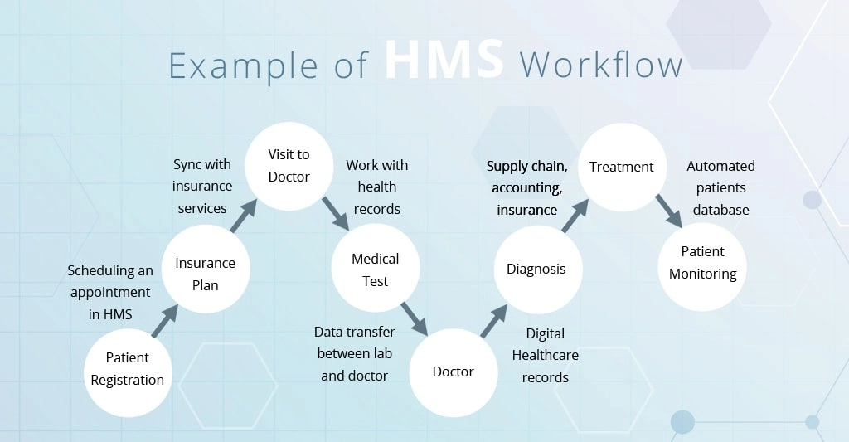

# **PROJECT MODULES**

# Add Information

# View Information

# Search Information

# Edit Information

# Delete Information

# **MODULE DESCRIPTION**

# **Add Information: -** To add patients details such as name, age, date of birth, etc. into the hospital database.

# **View Information**: - To view the patients details from the hospitals database.

# **Search Information**: - To search a specific patient details from the hospital database among N number of patients.

# **Edit Information**: - Can edit/modify any patient’s details from the hospitals database.

# **Delete Information**: - To delete any patients details after the discharge summary is issued.